An Overview of Collective Worship and Reflection at All Saints CE Primary School
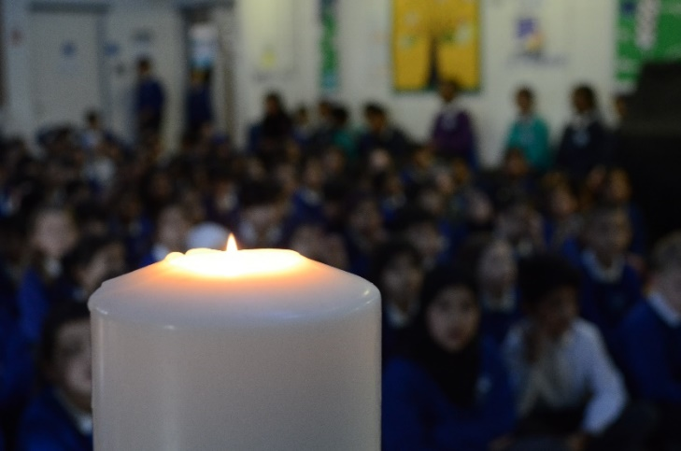
Collective worship has become a daily element of life at All Saints. Children and staff take the opportunity to reflect, share and respond to key themes. SLT lead two sessions per week in the main halls. We have made the decision to split the year groups in order to create a more intimate atmosphere and really ensure the themes are age relevant.

Children are key to these sessions. They contribute their ideas and then privately express their own thoughts on the themes within the central Reflection Space. Here children meet to discuss the ideas and they are able to write their ideas on labels provided. Children will often read each other’s ideas, prompting further discussions. Our year 6 leaders (head girl/boys, ambassadors & peer mentors) take turns to be present in the Reflection Space, during unstructured times, to provide friendship, support and guidance to other children.

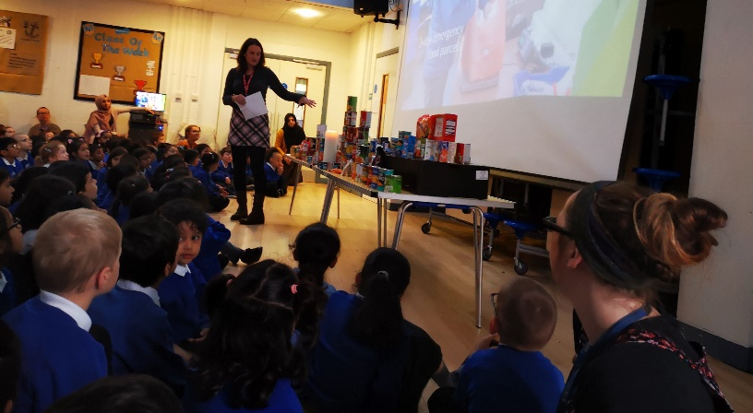
We also have key assemblies all together; although it is quite a feat to get all our pupils and staff into one space we feel it is crucial to the unity of the school. These sessions always include a key theme, sometimes led by pupils and/or SLT, celebration music and an opportunity to share the achievements of all.

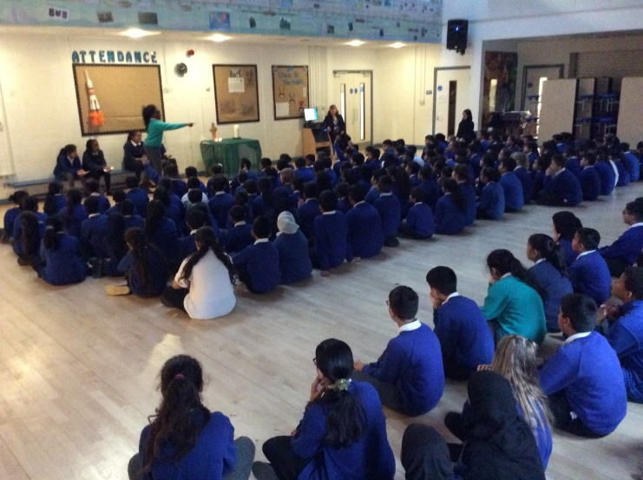
Pupils are also encouraged to take the lead with whole school collective worship. They plan on an agreed theme and then lead with a member of SLT providing background support.

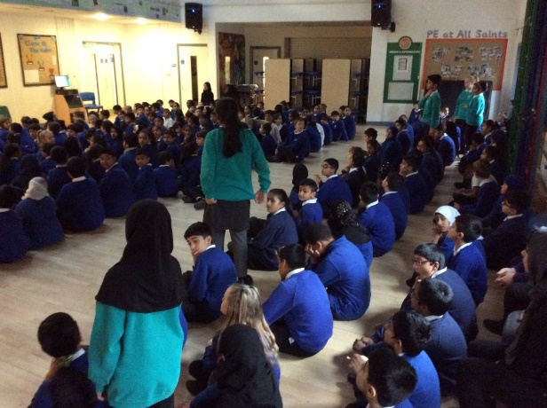

The pupils leading the assembly encouraged others listening to join in and respond to the topic of ‘Hopes and Aspirations’.

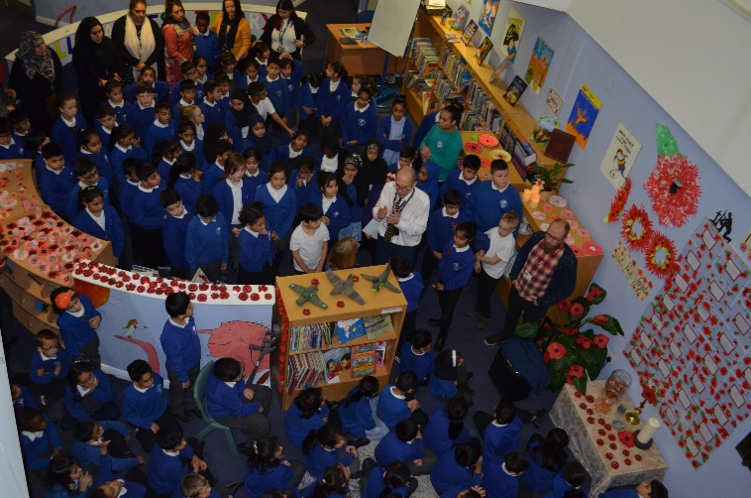
Remembrance Day and the key ideas associated with is are always carefully thought out. Last year we took part in the BBC’s Live Lesson, following a collective worship held in our Reflection space.

Our local Curate led the prayers, making this a very moving and
memorial occasion for staff and children. This year we will respond with a whole school liturgical cloth change just for the day and hold a collective worship in the hall.
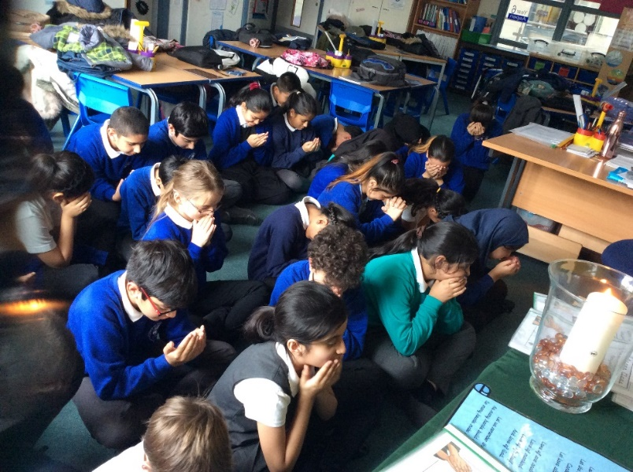
Every classroom has a pack of cloths, representing the colours from the liturgical calendar. Staff have received training on how the cloths should be represented and we feel it is a great way to introduce the Christian calendar in a practical and visual way. The cloths are a starting point for the each class’s personal reflection space. We have also introduced a candle. Again this provides a very clear indication to the whole class that lessons have ended and it is time for reflection. The children have written their own prayers and take turns to lead their class collective worship. It is also a fantastic time for any issues to be addressed and responded to in a positive way.

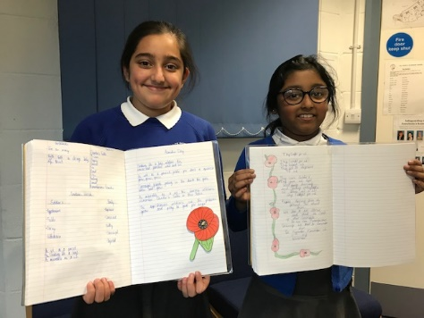
Pupils will also demonstrate their understanding of a shared Collective Worship, through a piece of work completed in class. The poem, In Flanders’ Fields was read out by a pupil in our Remembrance Day collective worship. The pupils then composed their own poems based on the same theme.

